**Computer Security Lab**

**Third Semester 2023**

**Lab 3: Use PGP to Create key pair, encrypt and decrypt messages**

**Name, Family Name: __Omer khan_**

**ID: 391007603 Section:______ Signature: _______________**

**Objective:** The objective of today’s lab is to learn how to use PGP to create key pair, encrypt, and decrypt messages.

What is Gpg4win?

Gpg4win enables users to securely transport emails and files with the help of encryption and digital signatures. Encryption protects the contents against an unwanted party reading it. Digital signatures make sure that it was not modified and comes from a specific sender.

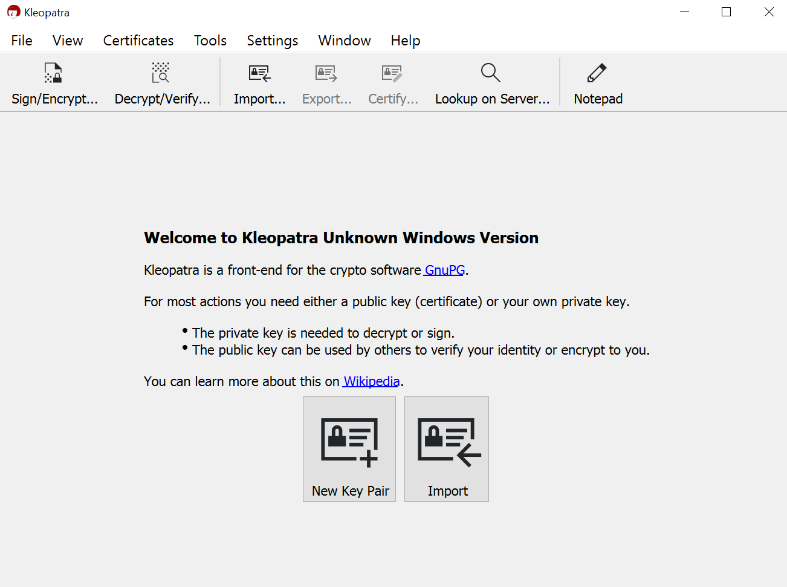

**(1)**

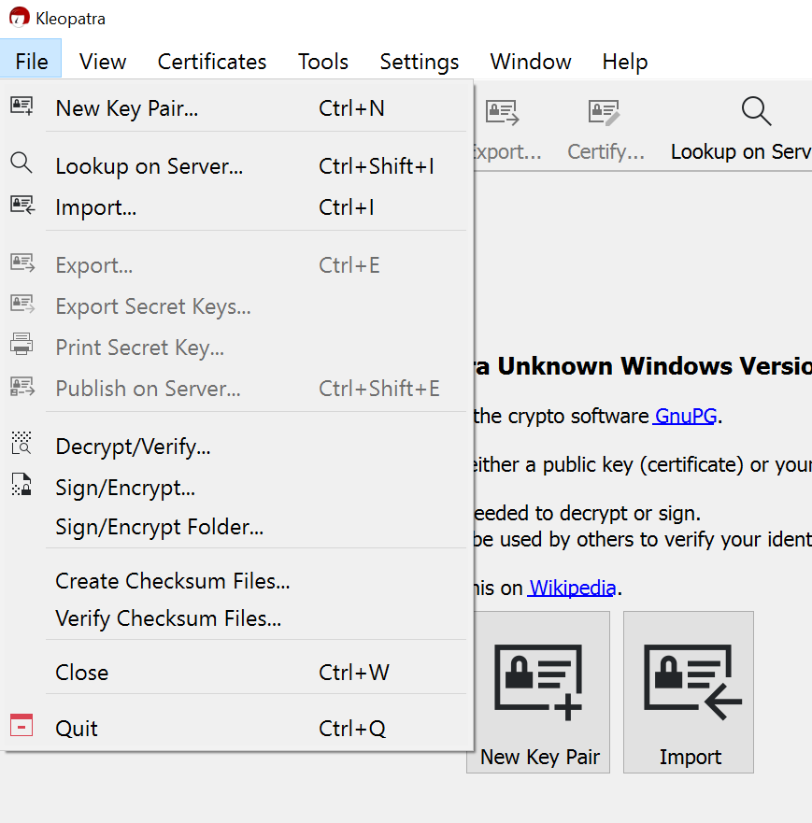

**(2)**

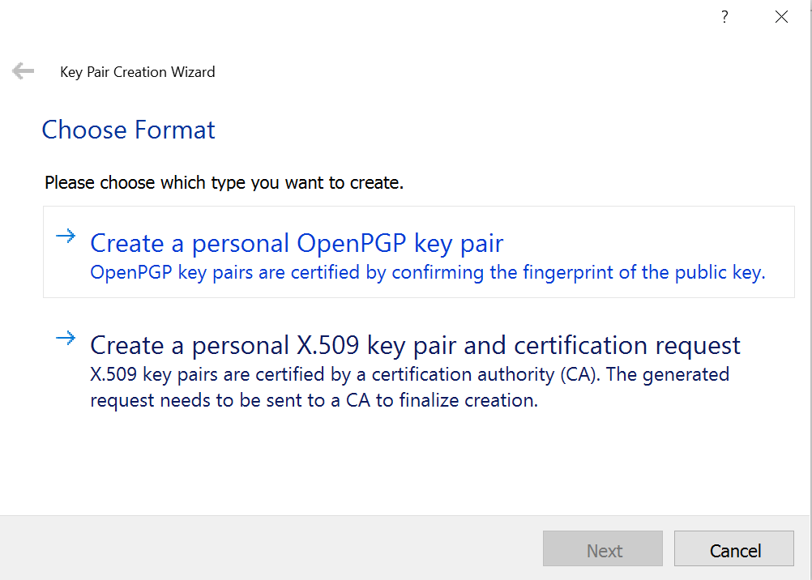

**(3)**

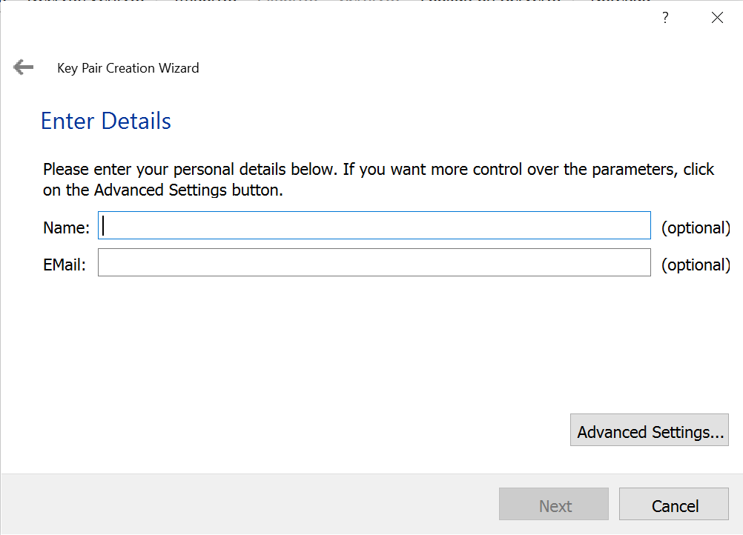

**(4)**

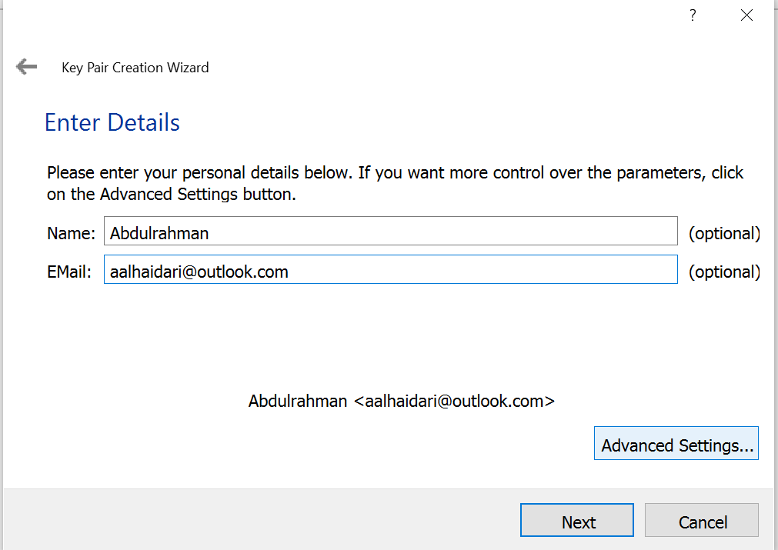

**(5)**

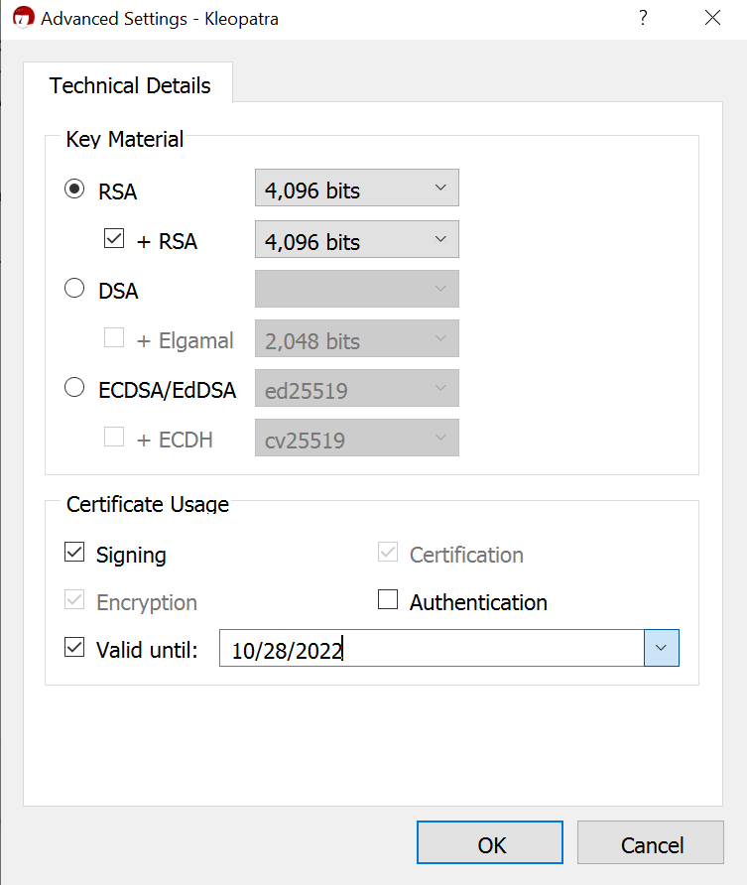

**(6)**

**Press OK, then Next**

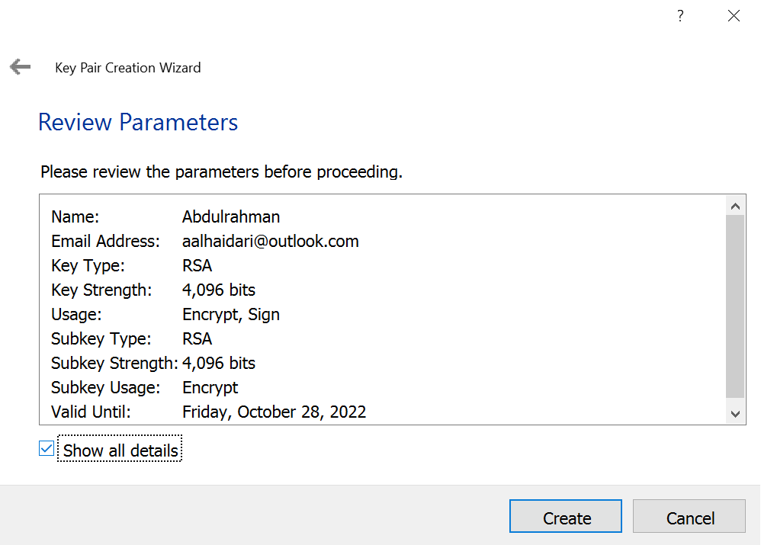

**(7) show details**

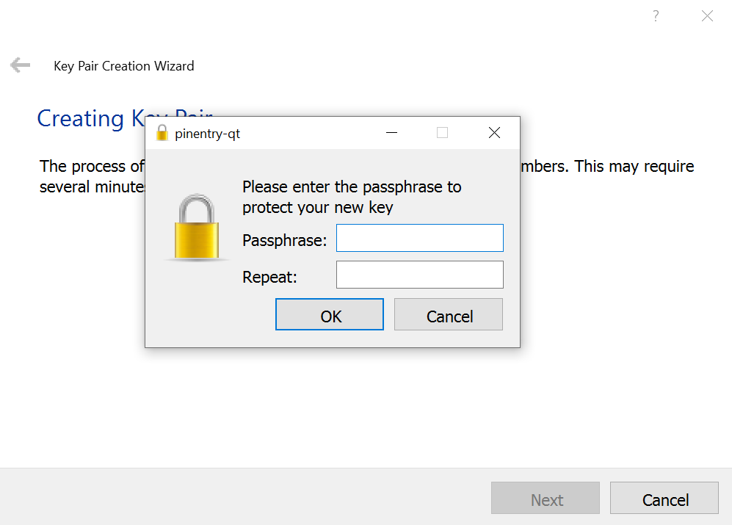

**(8) Enter a password**

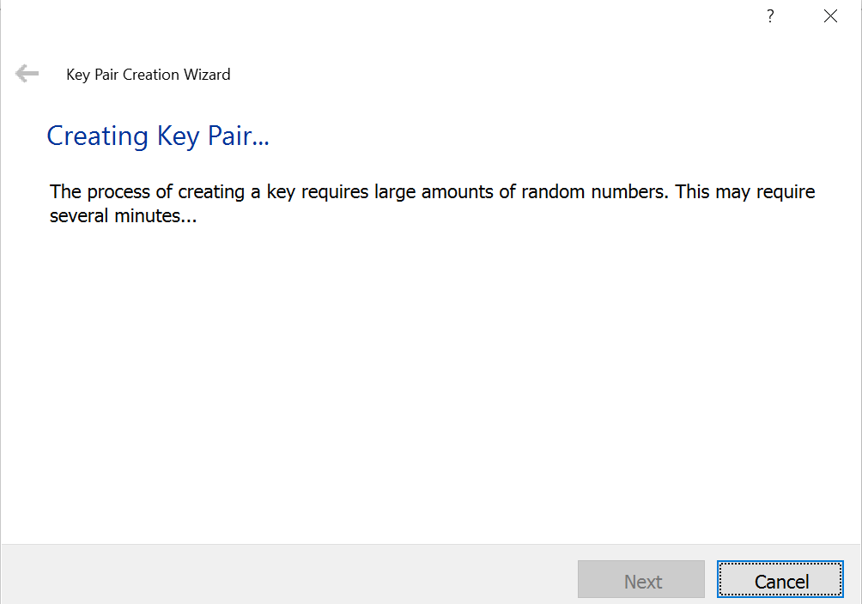

**(9) Wait for the key pairs to be created**

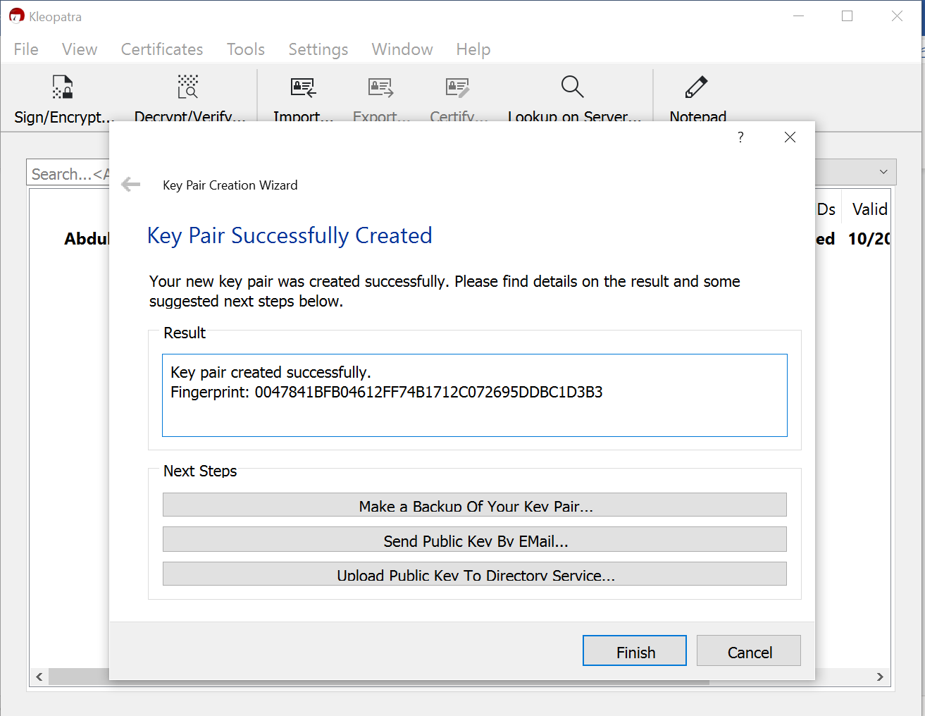

**(10) Your keys were created**

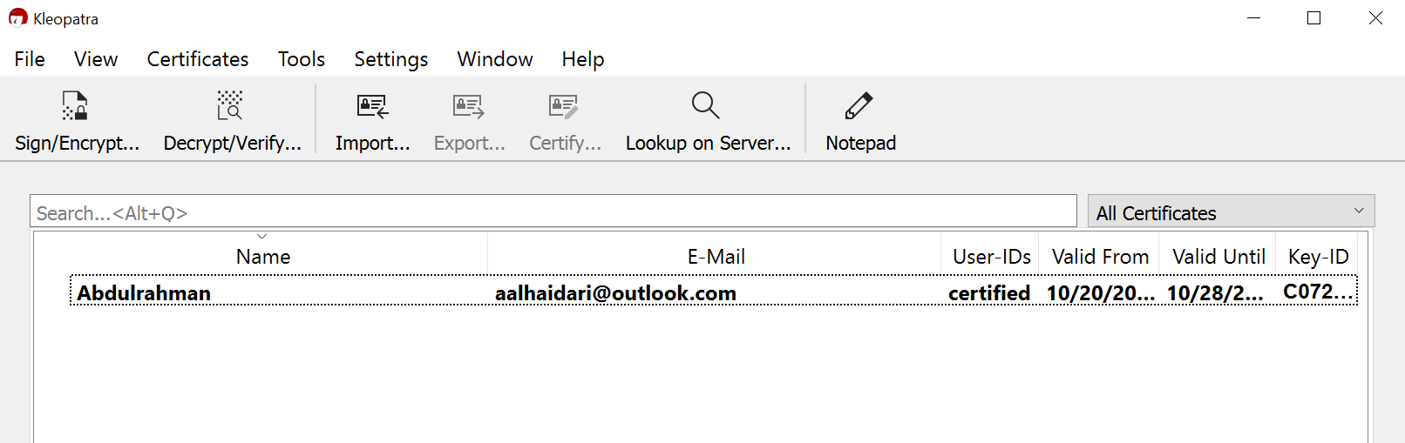

**(11)**

**Now you can export the keys and use them for encryption and decryption**

**Tasks:**

1. **Download Kleopatra Software**
2. **Create a key pair and save them at your computer**
3. **Encrypt a message using your friend public key**
4. **Send your public key to your friend**
5. **Decrypt a message that your friend sent you**
6. **Take screenshots of your work then submit to BB.**

**Download Kelopatra**

[**https://gpg4win.org/thanks-for-download.html**](https://gpg4win.org/thanks-for-download.html)

**Useful link**

<https://heimdalsecurity.com/blog/how-to-encrypt-email/>

<https://www.youtube.com/watch?v=lAblt1Qt_ng>

**Start your solution here**

**create public key**

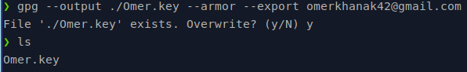

**encryput text using ,y public key:**

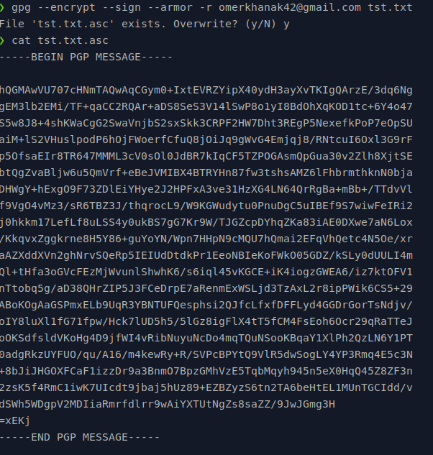

**import my friend key:**

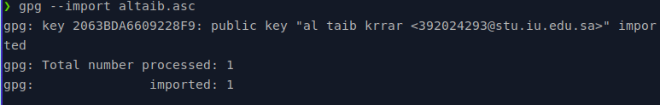

**decrypt using his key**

